Worksheet 1: Civil Rights Movement Map
You have the locations on your map but no events or dates. Your partner has the key events and dates but a blank map. Without looking at each others’ worksheet, communicate together so that you each have a completed map with key locations, events and dates on it. Correctly locate numbers 1-9 to the map.
Extension: colour the southern states (names in CAPS) & add the Freedom Rides bus route(s)
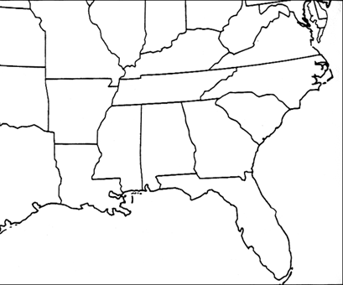
Topeka
(Kansas)
(Ohio)
(Indiana)
(Illinois)
(Oklahoma)
(Missouri)
(Texas)
WEST VIRGINIA
VIRGINIA
KENTUCKY
TENNESSEE
NORTH CAROLINA
SOUTH CAROLINA
(Florida)
ARKANSAS
LOUISIANA
MISSISSIPPI
GEORGIA
ALABAMA
Jackson
Albany
New Orleans
Drew
Birmingham
Montgomery
Oxford
Little Rock

Key locations, events & dates
1 | Homer Plessy arrested = Plessy vs Fergusson | 1896
2
3
4
5
6
7
8
9
Worksheet 2: Civil Rights Movement Map
You have the key events and dates but a blank map. Your partner has the locations on your map but no events or dates. Without looking at each others’ worksheet, communicate together so that you each have a completed map with key locations, events and dates on it. Correctly locate numbers 1-9 to the map.
Extension: colour the southern states (names in CAPS) & add the Freedom Rides bus route(s)

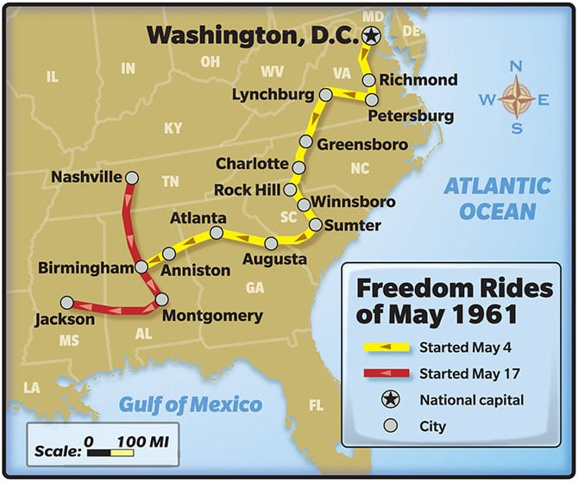
Key locations, events & dates
- New Orleans: Homer Plessy arrested = Plessy Vs Fergusson, 1896
- Topeka: Brown vs Board of Education, 1954
- Drew: murder of Emmitt Till, 1955
- Montgomery: Rosa Parks & the bus boycott, 1955
- Little Rock: Little Rock High School, 1957
- Jackson: Freedom ride bus terminates, 1961
- Albany: Albany Campaign, 1961
- Oxford: James Meredith & Ole Miss, 1962
- Birmingham: Birmingham Campaign, letter & children’s march 1962

